Skill Oriented Course-III



Report on

# Power BI

**B.TECH V SEM (2022-2026 BATCH)**

**Academic Year : 2024-2025**

**SRI VASAVI ENGINEERING COLLEGE (Autonomous )**

**Pedatadepalli,Tadepalligudem**

**Department of Artificial Intelligence and**

**Machine Learning**

[**SRI VASAVI ENGINEERING COLLEGE (Autonomous)**](https://app.uizard.io/prototypes/pbLBlo7qMyCrV0nQVqym)



[PEDATADEPALLI, TADEPALLIGUDEM](https://app.uizard.io/prototypes/pbLBlo7qMyCrV0nQVqym)

This is to certify Mr./Ms. bearing

RollNo of AIML Branch of **V semester** submitted the Report on as a part of **SKILL ORIENTED COURSE - III** (Course Code: V20SOC03) during the

academic year 2022-2026**.**

##### FACULTY Guide Head of the Department

**EXTERNAL EXAMINER**

**INDEX**

|  |  |  |
| --- | --- | --- |
| **S.No** | **Topic** | **page no.** |
| 1 | Introduction to Data and Power BI, Feature Engineering, Desktop Overview | 1-9 |
| 2 | Dataset Building, Basics of DAX | 10-12 |
| 3 | Dataset Creation, DAX Queries | 12-20 |
| 4 | Advanced DAX Queries, Data Visualization | 21-29 |
| 5 | Dashboard Creation, Publishing Reports, Power BI Apps | 30-41 |
| 6 | Project Development | 42-46 |

**INTRODUCTION TO DATA**

##### Overview of data, data types, and examples of structured vs. unstructured data :

**What is Data in Power Bi ?**

data refers to structured information imported from various sources for analysis and visualization, helping to uncover insights and trends. In Electrical and Electronics Engineering (EEE), feature engineering involves transforming raw data from sensors or systems into meaningful variables that improve model accuracy and system analysis. This process helps in predictive maintenance, performance monitoring, and system optimization. Both fields rely on data to drive informed decision-making and efficiency.

##### Data Classification in Power BI :

**Quantitative Data (Numerical Data)**

This includes numbers and values you can measure or count.

**Examples:** Sales figures, age, temperature, height, or the number of items sold.

**Qualitative Data (Categorical Data)**

This includes non-numerical information that describes qualities or characteristics.

**Examples:** Name, color, brand, or type of product.

**Discrete Data :**

These are countable values, meaning you can list or count them.

**Examples:** Number of people in a room, number of cars sold.

**Continuous Data :**

These are values that can be measured on a scale and can take any value within a range.

**Examples:** Height, weight, time, temperature.

Structured Data is easy to manage and analyze, like a well-organized table in Power BI. Unstructured Data is more complex and requires additional processing to make sense of, like analyzing customer feedback from social media posts.

Feature Engineering: Types and Importance in Data Analysis

Feature Engineering is the process of transforming raw data into features that better represent the underlying problem to the predictive models, resulting in improved model accuracy. It involves creating new features or modifying existing ones to improve the performance of machine learning models.

Types of Feature Engineering:

1. **Feature Creation:** Generating new features from existing data. For example, creating a new feature that represents the total number of words in a text document.
2. **Feature Transformation:** Modifying existing features to make them more useful. This can include scaling, normalization, or log transformations.
3. **Feature Selection:** Choosing the most relevant features to use in model training. This helps in reducing overfitting and improving model performance.
4. 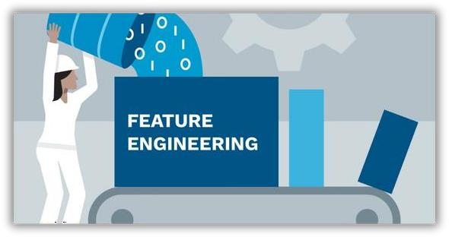**Feature Extraction:** Reducing the dimensionality of the data by extracting the most important information. Techniques like Principal Component Analysis (PCA) are commonly used for this purpose.

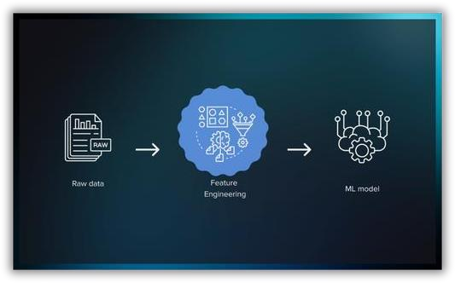

Importance in Data Analysis:

Feature engineering is a critical step in data analysis as it directly influences the effectiveness of machine learning models. By transforming raw data into meaningful features, it helps models identify patterns and relationships more effectively. Well-engineered features reduce noise, highlight relevant information, and provide a structured dataset that aligns closely with the problem at hand. This process often involves selecting, creating, and modifying features based on a deep understanding of the dataset and the domain, ensuring that the model can capture the underlying trends efficiently.

Moreover, effective feature engineering enhances a model's ability to generalize to unseen data, improving its performance across diverse scenarios. It minimizes the risk of overfitting by focusing on the most significant attributes and discarding irrelevant ones. This leads to faster model training and better interpretability of results, as the features used often have real-world significance. In practice, feature engineering can include techniques such as scaling, encoding, feature extraction, and polynomial transformations, all aimed at maximizing the predictive power of the dataset while maintaining simplicity and relevance.

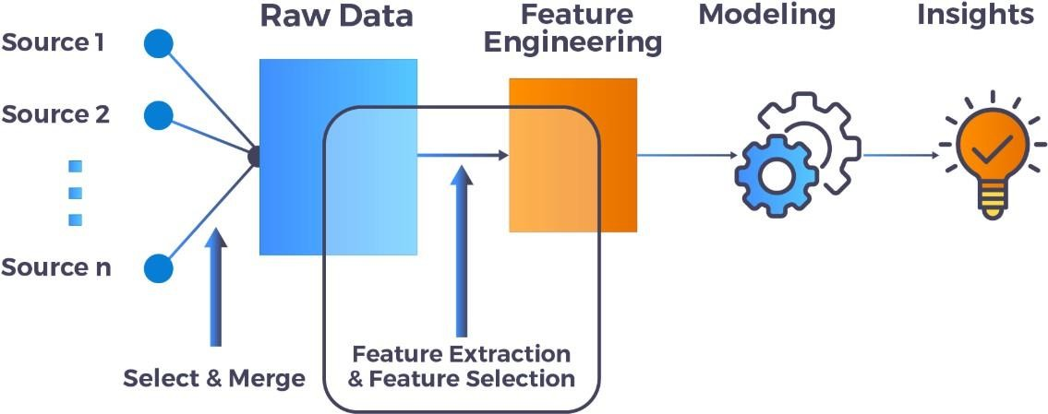

## Introduction to Power BI :

**Benefits, Use Cases, and Value in Data Visualization**

**Benefits of Power BI:**

1. **Ease of Use:** Power BI offers a user-friendly interface with drag-and-drop functionality, making it accessible to users with varying levels of technical expertise.
2. **Data Integration:** It supports a wide range of data sources, including Excel, SQL Server, and cloud-based data repositories.
3. **Interactive Visualizations:** Users can create interactive dashboards and reports that allow for real-time data exploration and analysis.
4. **Collaboration:** Power BI enables easy sharing and collaboration on reports and dashboards within an organization.

##### Use Cases:

1. **Business Intelligence:** Organizations use Power BI to create dashboards that provide a 360-degree view of their business performance.
2. **Data Analysis:** Analysts use Power BI to explore data, identify trends, and make data-driven decisions.
3. **Reporting:** Companies use Power BI to generate automated reports that can be shared with stakeholders.
4. **Customer Insights:** Businesses use Power BI to analyze customer data and gain insights into customer behavior and preferences.

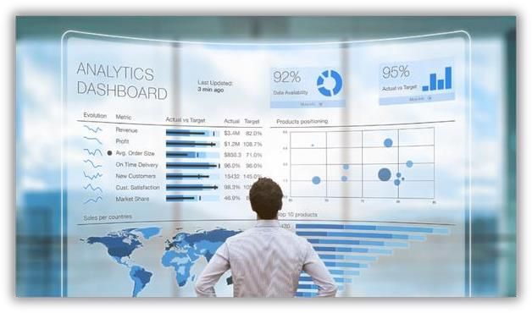

## Power BI Desktop Overview :

**Interface, Navigation, and Main Tools**

**Interface:**

* **Ribbon:** Located at the top, the Rib**Data and Model Views:** Located on the left sidebar, these views allow users to switch between Report, Data, and Model views.

##### Navigation:

* **Ribbon Navigation:** Users can navigate the Ribbon using keytips or by clicking on the tabs.
* **Fields and Visualizations:** Users can drag fields from the Fields Pane to the Visualizations Pane to create visualizations.
* **Report Canvas:** Users can add multiple report pages, arrange visualizations, and adjust layouts directly on the Canvas.

##### Main Tools:

1. **Data Import:** Power BI Desktop allows users to import data from various sources.
2. **Data Transformation:** Users can clean and transform data using built-in tools.
3. **Visualization Creation:** Users can create a wide range of visualizations, including charts, maps, and tables.
4. **Modeling:** Power BI Desktop provides tools for creating relationships between tables and managing data models.
5. 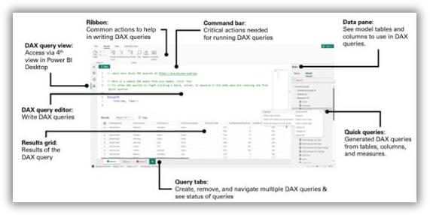**Filters:** Users can apply filters at different levels, including page, report, and visual levels.

5

**2. Connecting to Data Sources**

- **I m p o r t i n g s a l e s d a t a f r o m E x c e l a n d C S V f i l e s : -**

**Open Power BI Desktop**

Launch Power BI Desktop and open or create a new report.

1. Connect to Excel
   * Click on the **Home** tab.
   * Select **Excel Workbook** in the ribbon.
   * Navigate to the location of the Excel file and click **Open**.
   * In the Navigator window, you’ll see the available sheets or tables in the Excel file.
   * Check the tables/sheets you want to import.
   * Click **Load** to import or **Transform Data** to clean/edit the data before loading.
2. Connect to CSV
   * Click on the **Home** tab.
   * Select **Text/CSV** in the ribbon.
   * Browse and select the CSV file, then click **Open**.
   * Power BI will preview the data in the file
   * Click **Load** to import or **Transform Data** to make changes.

##### -Overview of data types and basic transformations.

1. Numeric Data Types
   * **Whole Number**: Integer values (e.g., 1, 100, -5).
   * **Decimal Number**: Floating-point numbers (e.g., 3.14, -0.56, 123.45).
   * **Fixed Decimal Number**: A fixed-point number with four decimal places, useful for financial data.
   * **Currency**: Represents monetary values; displayed with currency symbols.
2. Text
   * **Text/String**: Alphanumeric characters (e.g., "Customer Name", "Product123").

##### Date and Time

* + **Date**: Stores only dates (e.g., 2024-01-01).
  + **Time**: Stores only times (e.g., 14:30:00).
  + **Date/Time**: Stores both date and time (e.g., 2024-01-01 14:30:00).
  + **Date/Time/Timezone**: Includes timezone information.
  + **Duration**: Represents time intervals (e.g., 2:30:00 for 2 hours and 30 minutes).

##### Boolean

* + **True/False**: Logical values.

##### Binary

* + Used for storing files or binary objects, often imported but not transformed in Power BI.

##### Others

* + **Geographic**: Location-based fields for maps (e.g., country, city, latitude, longitude).
  + **Hierarchies**: Logical levels of data (e.g., Year > Quarter > Month).

#### 3. Basic Data Transformations

Power BI’s Power Query Editor provides an intuitive interface for performing basic data transformations. These transformations help clean, format, and prepare your data for analysis. Below are the key transformations you can use:

##### Renaming Columns and Tables

**Purpose:** Makes your data easier to understand.

Steps:

* + Right-click a column or table name and choose Rename.
  + Alternatively, double-click the name to edit it.

##### Changing Data Types

**Purpose:** Ensures data is interpreted correctly (e.g., dates for time-series analysis)

Steps:

* + Select a column.
  + In the ribbon, under the Transform tab, use the Data Type dropdown to assign the appropriate type (e.g., Text, Number, Date/Time).

##### Filtering Rows

Purpose: Exclude unnecessary rows. Steps:

* + **Click the filter icon on a column header.**
  + **Apply filters such as "equals," "greater than," or "contains.**

##### Removing Rows

Purpose: Eliminate irrelevant data (e.g., empty or error rows). Options:

* + **Remove Top/Bottom Rows: Under the Home tab, select Remove Rows > Remove Top/Bottom Rows.**
  + **Remove Duplicates: Select a column, then click Remove Duplicates.**

##### Adding Conditional Columns

**Purpose**: Create new columns based on logic (e.g., "if sales > 1000, then High").

Steps:

* + Go to the **Add Column** tab and select **Conditional Column**.
  + Define the conditions and output values.

##### Splitting Columns

**Purpose**: Break a column into multiple parts (e.g., split "First Last" into "First" and "Last").

Steps:

* + Select the column.
  + Go to the **Transform** tab and click **Split Column**.
  + Choose to split by delimiter (e.g., space, comma) or by position.

##### Merging Columns

**Purpose**: Combine multiple columns into one (e.g., concatenate first and last names).

Steps:

* + Select multiple columns (Ctrl + Click).
  + Go to the **Transform** tab and click **Merge Columns**.
  + Choose a separator (e.g., space, comma).

##### Custom Columns

**Purpose**: Create new columns using formulas.

Steps:

* + Go to the **Add Column** tab and select **Custom Column**.
  + Enter an expression using Power Query’s M language (e.g., [Sales] - [Cost] for profit).

##### Transposing Data

**Purpose**: Flip rows and columns.

Steps:

* + Select the entire table.
  + Go to the **Transform** tab and click **Transpose**.

##### Sorting Data

**Purpose**: Arrange rows in a meaningful order.

Steps:

* + Click on a column header.
  + Choose ascending or descending order.

## Data Modeling & DAX Basics

##### Data Modeling in Power BI:-

Data modeling involves organizing and creating relationships between your datasets to allow effective analysis and reporting.

Key Components of Data Modeling Fact Table:

* + Contains transactional or measurable data (e.g., sales, profits).
  + Examples: Sales, Revenue.

Dimension Table:

* + Contains descriptive data or attributes for analysis.
  + Examples: Products, Customers, Date.

##### Relationships

* **Purpose:** Connect tables to work together in visualizations.
* Types:
  + One-to-Many (most common): Links a dimension table to a fact table.
  + Many-to-Many: Used when there are overlapping keys in both tables.
  + One-to-One: Direct match between two tables.

##### Steps to Create Relationships:

1. Go to the Model view in Power BI.
2. Drag a field (e.g., CustomerID) from one table to its counterpart in another table.
3. Ensure correct Cardinality (One-to-Many, etc.) and Cross-Filter Direction (Single or Both).

Hierarchies

* Group related fields for easier navigation.

o Example: Date Hierarchy: Year > Quarter > Month > Day.

* Create by right-clicking a table field and selecting Create Hierarchy. Star Schema
* A common modeling approach in Power BI:

o Fact Table at the center, connected to multiple Dimension Tables.

Best Practices for Data Modeling

* Use a Star Schema where possible for simplicity and performance.
* Avoid creating many-to-many relationships unless necessary.
* Optimize table and field names for readability.
* Create surrogate keys for relationships when natural keys are unreliable.

**Introduction to DAX**

Basic DAX Concepts

**DAX (Data Analysis Expressions):**

DAX is a formula language used in Power BI, Excel, and SQL Server Analysis Services to create custom calculations and expressions.

**Key Concepts:**

**Measures:** Calculations created using DAX formulas that perform operations on data.

**Calculated Columns:** Columns added to tables using DAX formulas.

**Tables:** Sets of data organized into rows and columns.

**Expressions:** Formulas written using DAX functions and operators.

**Commonly used DAX functions**

DAX Functions

**SUM**: Adds all the numbers in a column.

**AVERAGE:** Calculates the average of the numbers in a column.

IF: Returns one value if a condition is true and another value if it is false.

**CALCULATE:** Modifies the filter context of a calculation.

**SUMX:** Returns the sum of an expression evaluated for each row in a table.

**DATEADD:** Returns a table with dates shifted by a specified interval.

**DAX Queries**

**Commonly used DAX queries**

* 1. **Basic Aggregation:** Aggregates data to produce a single value, like total revenue.
  2. **Conditional Logic:** Applies conditions to data to return different results, such as discount status.
  3. **Calculated Columns:** Adds new columns based on expressions, like calculating profit.
  4. **Date Calculations:** Extracts date-related information, such as the year from a date.
  5. **Text Manipulations:** Concatenates text fields, such as combining first and last names.

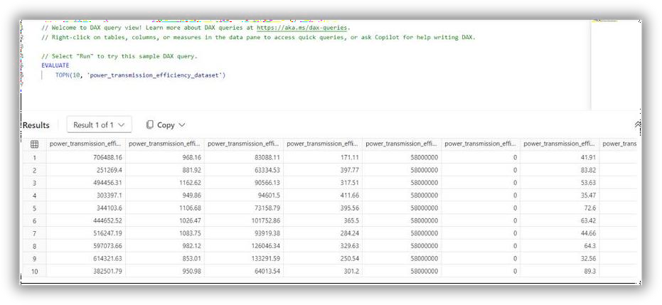

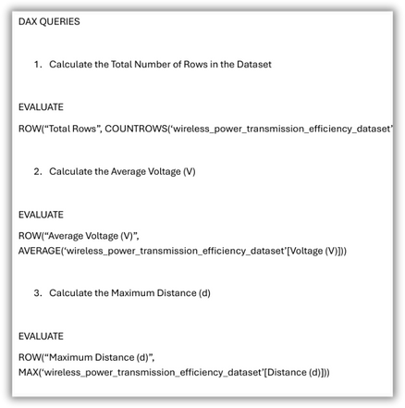

**Data Visualization Basics**

##### Power BI Visualization Pane :-

Data visualization in Power BI allows you to create meaningful charts, graphs, and dashboards to analyze and present data effectively. Below are the basics to get you started. The Visualization Pane in Power BI contains all the tools needed to build charts and customize visuals.

Types of Visuals:-

**Bar/Column Charts: Compare values across categories.**

* + Line Charts: Show trends over time.
  + **Pie/Donut Charts: Display proportions.**
  + Tables and Matrices: Present detailed data in tabular form.
  + **Cards: Highlight key metrics (e.g., Total Sales, Profit).**
  + Maps: Display geographic data.
  + **Scatter/Bubble Charts: Show relationships or distributions.**
  + Gauge Charts: Represent progress toward a goal.
  + **Slicers: Provide filters for interactivity.**

##### Building Visuals

Steps to Create Visualizations:-

1. **Import Data:**
   * **Ensure your dataset is loaded into Power BI.**
2. Select a Visual:
   * **From the Visualizations Pane, click a visual type (e.g., Bar Chart, Table).**
3. Drag and Drop Fields:
   * **Drag fields from the Fields Pane to different areas (e.g., Axis, Values, Legend).**
   * **Example:**
     + **Drag Year to Axis.**
     + **Drag Sales to Values.**
4. Customize:
   * **Use the Format Pane to adjust colors, fonts, axis titles, labels, and more.**
5. Visual Interactions

**Power BI visuals are interactive by default:**

* Clicking on a bar in a bar chart filters data in other visuals.
* Use the Edit Interactions option to control how visuals respond to interactions (Filter, Highlight)

1. Common Visual Customizations
   1. **Formatting**
   * Axis Titles: Add descriptive labels.
   * **Data Labels: Show values directly on the chart.**
   * Colors: Customize data point colors for clarity or emphasis.
   1. **Sorting**
   * Sort data ascending or descending by a specific column (e.g., Total Sales).
   1. **Conditional Formatting**
   * Apply colors based on rules or thresholds (e.g., red for negative profit).
   1. **Tooltips**
   * Hover over data points to show additional details.
   * **Customize tooltips by adding fields in the Tooltips area.**

#### Advanced Visualizations & Interactions

What Are Filters?

**Filters restrict the data shown in reports, visuals, or entire datasets based on specified conditions. They are applied in the Filters Pane and operate in the background, meaning users interact indirectly with them.**

**Types of Filters Visual-Level Filters**

* + **Scope: Apply only to the selected visual.**

##### Example: Show sales data for the "Electronics" category in a bar chart. Page-Level Filters

* + **Scope: Apply to all visuals on a specific report page.**

##### Example: Display data only for the year 2023 across a dashboard. Report-Level Filters

* + **Scope: Apply across all pages in a report.**

##### Example: Show data only for a specific region (e.g., North America).

**Filter Modes**

##### Basic Filtering:

* + **Select specific values to display.**

##### Example: Filter by Product Category = "Clothing".

o

1. Advanced Filtering:
   * Use conditions like "contains," "greater than," or "starts with."
   * Example: Sales Amount > 1000.
2. Top N Filtering:
   * Display the top or bottom N values based on a measure.
   * Example: Show the top 5 products by revenue.

##### Applying Filters

1. Open the Filters Pane in the report.
2. Drag a field to the desired filter level (Visual, Page, or Report).
3. Adjust filter settings to include/exclude specific values or conditions.

#### Slicers in Power BI:-

What Are Slicers?

Slicers are visual tools that allow users to interactively filter data directly on the report canvas. They act as on-screen filters that users can adjust in real time.

##### Types of Slicers

Categorical Slicers

* + Filter based on specific categories.
  + Example: Filter by Region (North, South, East, West). Numeric Slicers
  + Filter numeric fields with ranges.
  + Example: Sales values between 1000 and 5000. Date/Time Slicers
  + Filter data within a specific time frame.
  + Modes:
    - Between: Specify a date range.
    - Relative: Show data for the last X days, months, or years.
    - Dropdown/Hierarchy: Drill down by year, quarter, month, etc.

Hierarchical Slicers

* + Enable drill-down filtering across multiple levels.
  + Example: Filter by Continent > Country > State.

Adding a Slicer

1. Select the Slicer visual from the Visualizations Pane.
2. Drag a field (e.g., Region, Date) to the Field area.
3. Adjust slicer settings:
   * Dropdown or List view.
   * Enable multi-select or single-select option

Syncing Slicers

* + Purpose: Use the same slicer across multiple pages.
  + Steps:

1. Add a slicer to one page.
2. Go to View > Sync Slicers.
3. Enable syncing for desired pages. Drillthrough Pages
   * Purpose: Create pages dedicated to detailed views of data.
   * Steps:
4. Add fields to the Drillthrough Filters section of a report page.
5. Create visuals on the page.
6. Right-click a data point in another visual and choose Drillthrough.

#### Enhancing Report Interactivity with Buttons and Bookmarks

##### Buttons in Power BI

Buttons are interactive elements that allow users to navigate between pages, apply filters, or reset visuals.

##### Steps to Add Buttons:

1. Insert Button:
   * Go to the Insert menu > Select Button (Blank, Back, Reset, or Navigation).
2. Customize Button:
   * Use the Format Pane to:
     + Add a title or icon.
     + Style the button (color, size, font, etc.).
3. Add an Action:
   * Enable Action under the Format Pane.
   * Choose the type of action (e.g., Bookmark, Page Navigation, Drillthrough).
   * Link it to the target (e.g., a specific bookmark or report page).

##### Common Button Actions:

* + Bookmark Navigation: Link to specific bookmarks for dynamic visual changes.
  + Page Navigation: Move between report pages.
  + Drillthrough: Open detailed data pages.
  + Reset Filters: Reset slicers and visuals to their default state.

•

#### Bookmarks in Power BI

Bookmarks save the current state of visuals, filters, and slicers, enabling dynamic interactivity. Steps to Create a Bookmark:

1. Set Visual State:
   * Adjust visuals, filters, and slicers to the desired view.
2. Open the Bookmarks Pane:
   * Go to View > Enable Bookmarks Pane.
3. Add Bookmark:
   * Click Add Bookmark and name it (e.g., "Default View," "Detailed View").
4. Organize Bookmarks:
   * Use Groups to organize bookmarks for easier navigation.
   * Rearrange the order as needed.

Using Bookmarks with Buttons:

* + Link a button to a bookmark via the Action setting.
  + Example: A button labeled “View Details” can toggle between a summary chart and a detailed table.
  1. Toggle Features with Buttons and Bookmarks
     + Show/Hide Visuals:
       - Create bookmarks for "Visible" and "Hidden" states of a visual.
       - Link these bookmarks to buttons for toggling visibility.
     + Dynamic Visual Changes:
       - Use buttons to switch between chart types (e.g., Bar Chart vs. Line Chart).

#### Creating a Dynamic and Navigable Sales Report

##### Planning the Sales Report Layout

* + - Pages:
      * Overview: Key metrics (Total Sales, Revenue, Profit Margin).
      * Trends: Sales over time (line chart, area chart).
      * Details: Sales by region, product, or customer.
      * Filters: A dedicated page with slicers for user-driven analysis.
    - Navigation Features:
      * Add buttons for page transitions.
      * Sync slicers across pages for consistent filtering

##### Building the Sales Report

Overview Page

* + - Visuals:
      * KPI Cards: Total Sales, Revenue, Profit.
      * Bar Chart: Sales by Region.
      * Donut Chart: Sales Distribution by Product Category.
    - Interactions:
      * Add slicers for Date, Region, and Category.
      * Include a Reset Filters button.Trends Page
    - Visuals:
      * Line Chart: Monthly Sales.
      * Area Chart: Cumulative Sales.
    - Interactions:
      * Add a Drillthrough button to navigate to a product-specific detailed page.
      * Enable time slicers (e.g., Year, Quarter). Details Page
    - Visuals:
      * Table: Sales by Product, Region, or Customer.
      * Bar Chart: Top 10 Products by Revenue.
    - Interactions:
      * Add a Back to Overview button.
      * Include a slicer to filter by specific sales representatives. Filters Page
    - Setup:
      * Add slicers for all key fields (e.g., Date, Product, Region).
      * Sync slicers to other pages for consistent filtering.
    - Interactivity:
      * Add a Home Button for navigation. Adding Navigation

1. Navigation Buttons:
   * Insert buttons for "Overview," "Trends," "Details," and "Filters."
   * Link each button to its corresponding page using the Page Navigation action.
2. Back Button:
   * Use the built-in Back Button for drillthrough navigation.
3. Menu Design:
   * Create a navigation menu with buttons and icons. Adding Dynamic Interactions
4. Dynamic Charts:
   * Add buttons to toggle between different chart views (e.g., Sales by Region vs. Sales by Category).
5. Dynamic Filters:
   * Use slicers and bookmarks for tailored data views.
   * Example: A bookmark toggles between "Top 10 Products" and "All Products."
6. Tooltips:
   * Use custom tooltip pages for additional insights when hovering **over visuals.**

## Power BI Service & Publishing Reports

###### Introduction to Power BI Service:-

Power BI Service is the cloud-based platform where Power BI reports, dashboards, and datasets are hosted, shared, and collaborated on. It provides tools for accessing and managing data in real-time and enables seamless collaboration across teams and organizations.

**Understanding the Features of Power BI Service:-**

Key Features:- Dashboards

* + - Description: A collection of visuals (tiles) pinned from reports for a summarized view of data.
    - Purpose: Highlight key metrics and KPIs in a single view.
    - Interactivity: Dashboards can link to detailed reports or external URL

Reports

* + - Description: Interactive, multi-page visuals created in Power BI Desktop and published to the service.
    - Purpose: Provide in-depth analysis with slicers, filters, and drillthrough options.

Datasets

* + - Description: Data models used to build reports and dashboards.
    - Purpose: Centralized data source for consistent reporting.

Publishing Sales Reports from Power BI Desktop to the Service

Preparing a Report for Publishing

1. Save Your Work:
   * Ensure your Power BI Desktop (.pbix) file is complete and saved.
2. Review Data Refresh Settings:
   * Verify that the data source credentials are valid and update them if necessary.
   * For cloud data sources (e.g., SharePoint, SQL Azure), configure credentials.
   * For on-premises data sources, set up a Power BI Gateway.

Publishing a Report

1. Sign In to Power BI Service:
   * Open Power BI Desktop.
   * Click File > Sign In and log in with your Microsoft account.
2. Publish the Report:
   * Click File > Publish > Power BI Service.
   * Select the target workspace (e.g., My Workspace or a shared workspace).
   * Wait for the upload to complete. A confirmation message will appear.

Configuring Datasets in Power BI Service

1. **Access the Dataset:**
   * Go to the Datasets tab in Power BI Service.
2. Schedule Data Refresh:
   * Open the dataset settings.
   * Configure the refresh schedule (daily, hourly, etc.).
3. Set Up a Gateway (if needed):
   * Install and configure an On-Premises Data Gateway for non-cloud data sources.

**Sharing and Collaboration in Power BI**

Power BI facilitates seamless sharing and collaboration among team members and stakeholders. Using features like workspaces, apps, and sharing options, users can work together effectively to explore, analyze, and act on data insights.

Sharing Reports with Colleagues

Sharing Reports via Power BI Service

You can directly share reports created in Power BI Desktop after publishing them to Power BI Service.

Steps to Share a Report:

1. **Publish the Report:**
   * Publish your Power BI Desktop report to Power BI Service.
   * Locate the report in the chosen workspace.
2. Share the Report:
   * **Open the report in Power BI Service.**
   * Click the Share button (top-right corner).
   * **Enter the email addresses of colleagues or groups.**
   * Choose sharing permissions:
     + **Allow recipients to reshare: Recipients can share the report further.**
     + Build permissions: Recipients can use the report’s dataset to create new reports.
   * **Add a personal message and click Send.**

Key Notes:

* + - **Recipients receive an email with a link to the shared report.**
    - **Users must have Power BI Pro licenses to share or access shared reports, unless the report resides in a Premium workspace.**

**Exporting Reports**

For offline sharing, export reports in formats like PDF, PowerPoint, or Excel.

Steps to Export:

1. Open the report in Power BI Service or Desktop.
2. Select File > Export.
3. Choose a format:
   * PDF: Export visuals and layouts as a static document.
   * PowerPoint: Export visuals to slides for presentations.
   * Excel: Export data tables to Excel for further analysis.

Embedding Reports

Embed Power BI reports in other platforms for broader sharing. Options:

1. Embed in SharePoint Online:
   * Use the Embed in SharePoint Online option to integrate reports into SharePoint pages.
2. Embed in Teams:
   * Add reports to Microsoft Teams channels for real-time collaboration.
3. Embed in a Website:
   * Generate embed codes to include reports in websites (requires appropriate permissions).

## Exploring Workspaces and Apps for Collaboration

* 1. Workspaces in Power BI

Workspaces are collaborative environments for teams to create, share, and manage Power BI content.

**Types of Workspaces:**

* + 1. My Workspace:
       - A personal workspace for individual reports and dashboards.
       - Ideal for testing or private analysis.
    2. Shared Workspaces:
       - Collaborative spaces for teams or projects.
       - Content can include datasets, reports, dashboards, and apps.
       - Permissions are role-based (Admin, Member, Contributor, Viewer**).**

Managing Workspaces:

1. **Create a Workspace:**
   * In Power BI Service, go to the Workspaces tab and click Create a Workspace.
   * Assign a name and logo.
   * Add members and assign roles.
2. Add and Share Content:
   * Publish or upload reports, datasets, and dashboards to the workspace.
   * Use role-based permissions to manage access and editing rights**.**
3. Monitor Activity:
   * View workspace usage and content metrics to understand how reports are utilized**.**

##### Apps in Power BI

Apps are packaged collections of reports and dashboards shared with end users for easy access.

Features:

* **Centralized Access:** Users can access all relevant content in one place**.**
* **Custom Branding:** Customize the app’s appearance to align with organizational branding.
* **Real-Time Updates:** Automatically reflect updates made in the associated workspace.

**Steps to Create and Share an App:**

1. **Prepare the Content:**
   * Finalize reports and dashboards in the workspace.
   * Ensure all visuals and filters are configured correctly**.**

#### Create the App:

* + Open the workspace and click Create App.
  + Add a name, description, and logo.
  + Select the content (reports, dashboards) to include.

#### Share the App:

* + Publish the app and share it with users.
  + Specify access permissions (specific users, groups, or entire organizations).

#### Accessing Apps:

* Users can find shared apps under the Apps tab in Power BI Service.
* Apps provide a simplified view for non-technical users, hiding the complexity of the underlying workspace

1. Calculate Total Energy Consumption:
   * TotalEnergy = SUM(EnergyData[Consumption])
2. Average Load Balancing:
   * AverageLoad = AVERAGE(GridData[Load])
3. Maximum and Minimum Consumption:
   * MaxConsumption = MAX(EnergyData[Consumption])
   * MinConsumption = MIN(EnergyData[Consumption])
4. Efficiency Ratio:
   * Efficiency = SUM(EnergyData[Output]) / SUM(EnergyData[Input])

These DAX queries help in analyzing and visualizing key performance metrics of a smart grid efficiently and effectively.

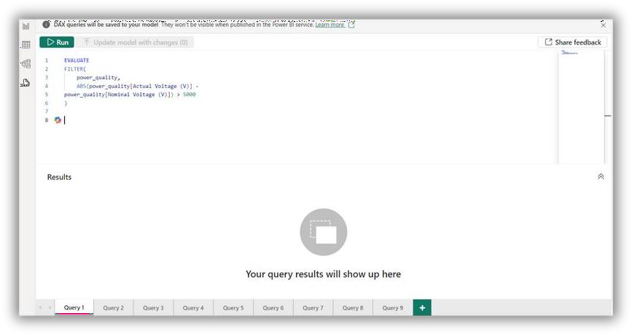

**Applying DAX queries to generate insights.**

#### Writing DAX queries on each feature for complete data analysis.

1. Calculate Total Energy Consumption:
   * TotalEnergy = SUM(EnergyData[Consumption])
2. Average Load Balancing:
   * AverageLoad = AVERAGE(GridData[Load])
3. Maximum and Minimum Consumption:
   * MaxConsumption = MAX(EnergyData[Consumption])
   * MinConsumption = MIN(EnergyData[Consumption])
4. Efficiency Ratio:
   * Efficiency = SUM(EnergyData[Output]) / SUM(EnergyData[Input])

These DAX queries help in analyzing and visualizing key performance metrics of a smart grid efficiently and effectively.

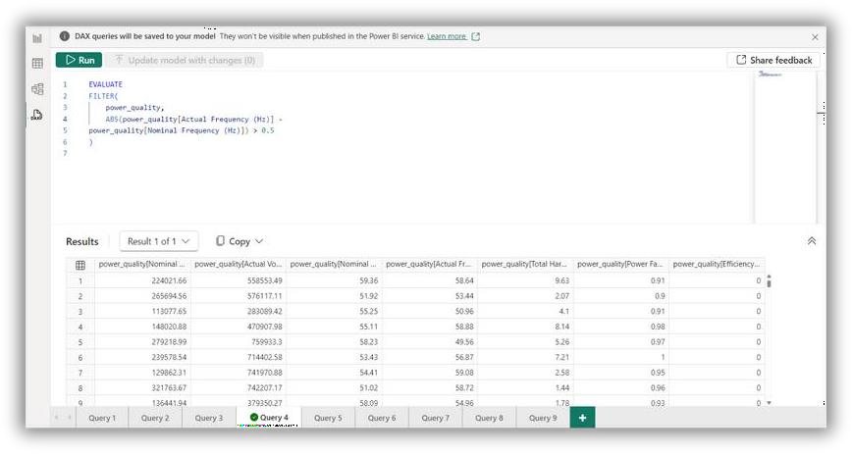

## IoT Product Performance Efficiency, Advanced DAX Queries, Data Visualization

#### IoT Product Performance:

IoT performance refers to how well Internet of Things (IoT) devices and systems function in terms of speed, reliability, and efficiency. It encompasses the ability to handle data transfer between devices, maintain stable connections, and operate within the expected parameters without significant downtime. Key performance indicators often include latency, throughput, and power consumption. Effective IoT performance ensures seamless operation and enhances the user experience.

IoT devices include *smart sensors* for monitoring environmental parameters,

*actuators* for executing physical tasks, *smart meters* for accurate utility tracking,

*wearable devices* for health monitoring, and *industrial IoT devices* for process automation. Performance factors to consider are *latency* (response time),

*throughput* (data transfer rate), *reliability* (consistency of performance), and

*power consumption* (energy efficiency). These factors ensure optimal functionality and user experience.

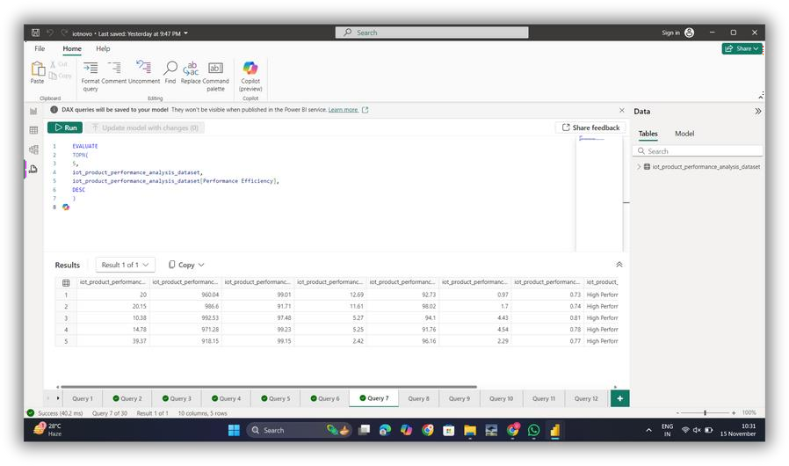

**Dataset Building for IoT Performance:**

Developing a dataset focused on IoT performance and efficiency.

1. Define Objectives:

- Identify the key metrics to track, such as response time, data throughput, reliability, and power consumption.

1. Data Collection:

- Use smart sensors and IoT devices to gather real-time data on environmental conditions and device performance.

1. Data Storage:
   * Store the collected data in a cloud-based platform for easy access and analysis.
2. Data Cleaning:
   * Remove any irrelevant or duplicate data to ensure accuracy and consistency.
3. Data Analysis:
   * Use tools like Power BI to visualize and analyze the data, highlighting trends and insights on IoT performance and efficiency.

These steps form the foundation of creating a robust dataset that can drive insights and improvements in IoT applications.

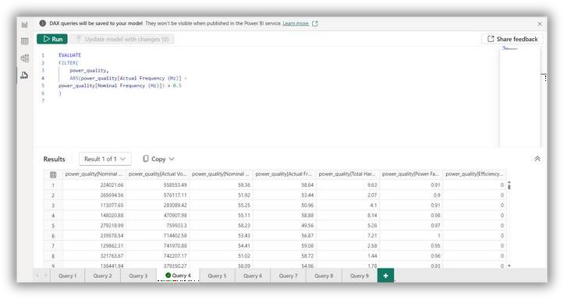

## Advanced DAX Queries :

Writing complex DAX queries to capture detailed insights into IoT performance.

1. **Understand Metrics:**

- Identify the key performance indicators (KPIs) such as response time, data transfer rates, reliability, and energy efficiency.

1. Data Modeling:
   * Structure your data model in Power BI to include all relevant IoT data sources and relationships.
2. Basic DAX Functions:
   * Start with simple functions like SUM, AVERAGE, and COUNT to aggregate data.
3. Advanced DAX Functions:
   * Use advanced DAX functions like CALCULATE, FILTER, and ALL to create complex queries that can filter and evaluate data based on multiple conditions.
4. Visualizing Insights:
   * Implement these DAX queries into Power BI to create interactive reports and dashboards that display detailed insights into IoT performance.

This streamlined process helps in creating powerful DAX queries that provide meaningful insights into the performance and efficiency of IoT systems.

**Data Visualization:**

Creating visuals based on relational data and DAX queries for IoT datasets

1. **Prepare Relational Data:**
   * Organize your IoT data into tables, ensuring each table represents a different aspect of the data (e.g., sensors, devices, performance metrics).

- Establish relationships between these tables using common fields, such as device IDs or timestamps.

1. Develop DAX Queries:
   * Write DAX (Data Analysis Expressions) queries to calculate necessary metrics and insights, such as average response time or total data transferred.

- Use functions like SUM, AVERAGE, and CALCULATE to perform these calculations.

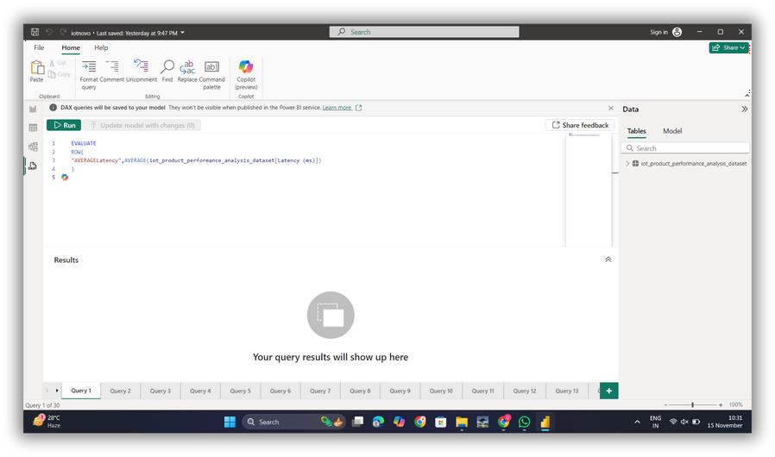

1. Create Visuals:

* Use Power BI to create visualizations based on your DAX queries and relational data.
* Choose appropriate visual types (e.g., line charts for trends, bar charts for comparisons) to effectively display your insights.
* Combine multiple visuals in dashboards to provide a comprehensive view of IoT performance and efficiency.

These steps ensure you can translate complex data relationships and analyses into intuitive and informative visuals for your course.

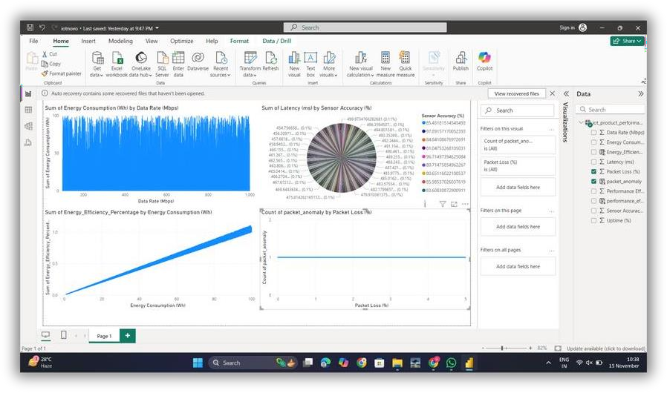

# Electric Vehicle Performance

#### Overview of EV performance metrics and efficiency factors.

1. **Battery Health and Capacity :** Tracks the battery’s state of charge and degradation directly impacting the EV’s range and lifespan.
2. **Energy Consumption :** Measures electricity usage providing a insights into the EV's efficiency under different driving conditions.
3. **Range and Mileage :** Assesses the max distance per charge , influenced by a battery condition, driving style, and environmental factors.
4. **Charging Efficiency :** Monitors charging speed & efficiency across charging types , affecting vehicle uptime and convenience.
5. **Regenerative Braking Efficiency :** Evaluates energy recovery during braking, which increases the efficiency.
6. **Max Speed and Acceleration Impact :** Analyzes how the high speeds and the rapid acceleration which affect the battery drain and overall range, helping to balance performance with efficiency.

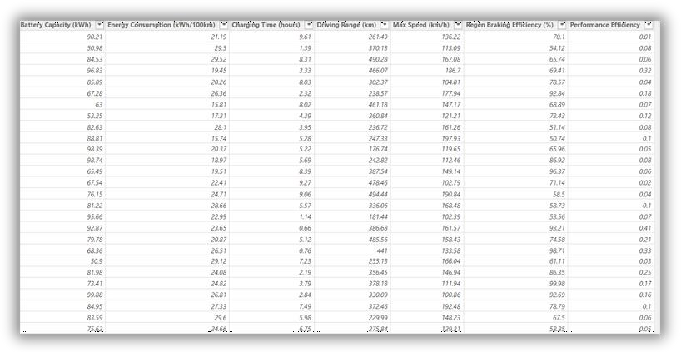

**Dashboards for EV Performance Analysis :**

1. **Data Integration :** Import and organize data from sources such as IoT sensors, telematics, & charging stations for comprehensive view of EV performance.
2. **Dashboard Layout :** Design a user-friendly layout by grouping key metrics like battery health, range, energy consumption, & charging efficiency into distinct sections.
3. **Visualizations :** Use charts, gauges, and trend lines to visualize metrics such as maximum speed impact, regenerative braking efficiency, and energy usage

over time.

1. **Real-Time Data Updates :** Enable real-time or near real-time data refreshes to monitor ongoing performance and receive up-to-date insights.
2. **Interactive Filters:** Add filters for conditions like speed ranges, charging types,

and driving scenarios to allow in-depth, customized analysis across variables impacting EV performance.

**Examples :**

* 1. Charging time and Battery capacity
  2. Driving Range and Max Speed
  3. 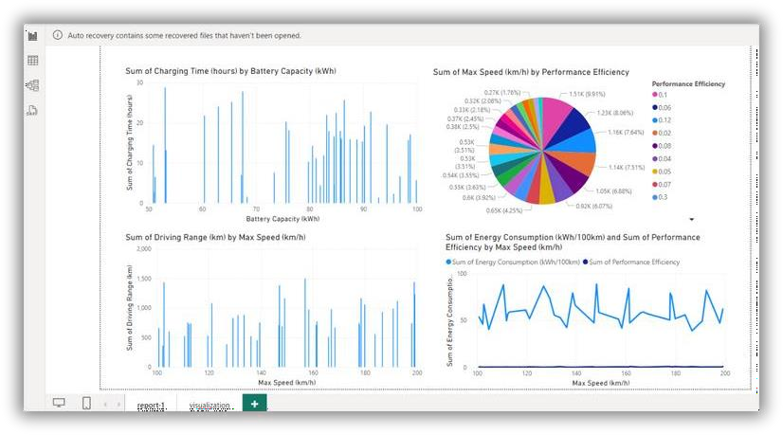Max Speed and Performance Analysis

### DAX Queries For EV Performance Analysis :

Battery Capacity vs. Driving Range Correlation :

"DrivingRangePerCapacity",DIVIDE(SUM('ev_performance'[Driving Range (km)]), SUM('ev_performance'[Battery Capacity (kWh)]))

Average Battery Capacity by Max Speed Range :

ev_performance,"SpeedRange", SWITCH(TRUE(), [Max Speed (km/h)] <= 150, "100-150", [Max Speed (km/h)] <= 200, "150-200", "200+",

[SpeedRange],"AvgBatteryCapacity", AVERAGE(ev_performance[Battery Capacity (kWh)])

Total Driving Range for Top 10 Most Efficient Vehicles :

ev_performance,

ev_performance[Battery Capacity (kWh)], "TotalDrivingRange", SUM(ev_performance[Driving Range (km)]) , [TotalDrivingRange], DESC

**Energy Consumption for Vehicles with Regen Efficiency Over 70% :** ev_performance[Regen Braking Efficiency (%)], "EnergyConsumption", AVERAGE(ev_performance[Energy Consumption (kWh/100km)]) , ev_performance[Regen Braking Efficiency (%)] > 70

Top 5 Vehicles by Max Speed and Driving Range Combined Score :

ev_performance,

"CombinedScore", ev_performance[Max Speed (km/h)] + ev_performance [Driving Range (km)] , [CombinedScore], DESC )

Ratio of Battery Capacity to Charging Time :

ev_performance, "BatteryToChargingTimeRatio",

DIVIDE(ev_performance[Battery Capacity (kWh)], ev_performance[Charging Time (hours)])

**Publishing Reports :**

1. **Customize Visuals for Key Metrics :** Tailor visuals for EV - specific metrics like battery health, energy consumption, and regenerative braking, ensuring they

are clear and impactful.

1. **Set Automatic Data Refresh :** Scheduling the regular data refreshes to keep the performance metrics current especially important for monitoring the metrics such as range, charging cycles, and real-time energy usage.
2. **Define User Access Levels :** Assign permissions so that different stakeholders & engineers, fleet managers, or customers to see only relevant data, protecting sensitive information.
3. **Embed Reports for Accessibility :** Integrates Power BI reports into apps or web portals allowing easy access for users who need insights on EV performance

across various devices.

1. **Enable Metric-Based Alerts :** Configure alerts for critical metrics, such as when battery health drops below a certain level or energy consumption spikes, to

prompt timely action.

1. **Solicit User Feedback for Refinement :** After publishing, gather the feedback to enhance report features and ensures the dashboard meets user needs, refining visualizations and data insights for optimal EV performance analysis.

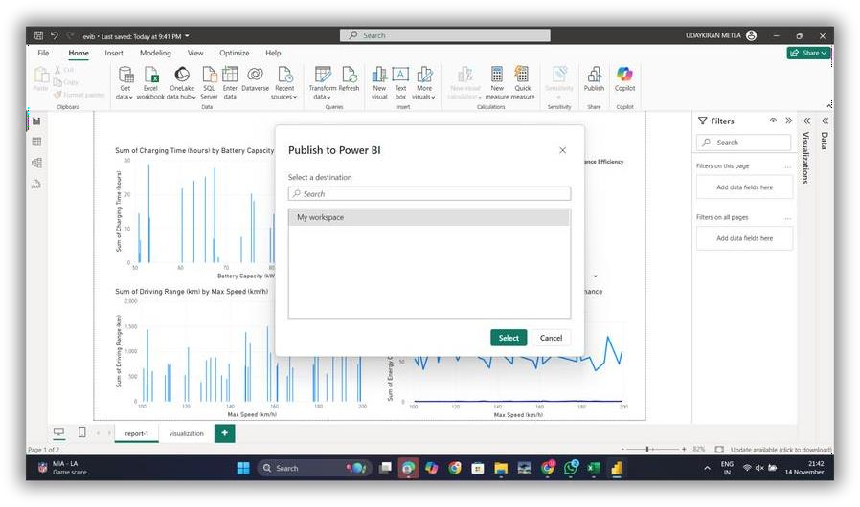

## Student Project Development

##### Guided Project Start:

Students choose a real-time dataset for analysis.

**Dynamic Data**: Students work with real-time datasets that continuously update, reflecting current trends and behaviors.

**Diverse Data Sources**: Real-time data is often pulled from sources like IoT devices, social media, or live transaction databases.

**Timely Insights**: Analyzing real-time data allows students to gain actionable insights that can be used for immediate decision-making.

**Hands-on Learning**: Students learn how to process, visualize, and interpret live data, enhancing their understanding of real-time analytics.

**Real-World Application**: Working with real-time data prepares students for scenarios where immediate decision-making is crucial, such as in business or technology environments.

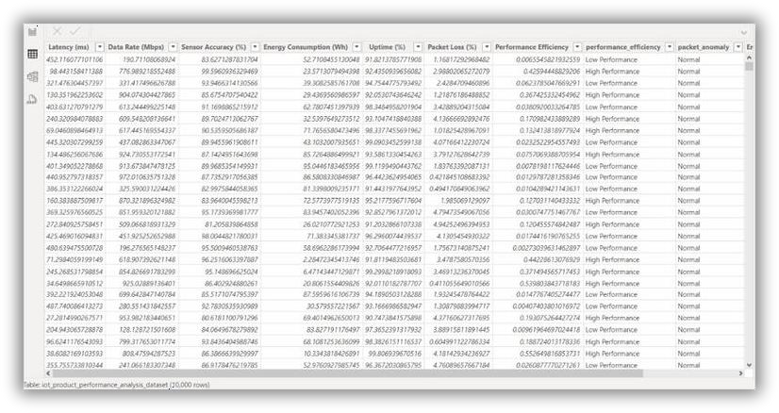

## Instructions on relevant feature extraction,

##### building data values, and DAX queries.

In Power BI, feature extraction, building data values, and utilizing DAX (Data Analysis Expressions) are critical steps in transforming raw data into actionable insights. Feature extraction involves selecting relevant columns or creating new columns that capture significant patterns and characteristics from the dataset, making it easier to analyze key variables. For example, if students are working with sales data, they might create features like monthly sales growth, customer lifetime value, or product popularity trends. This process may involve splitting date columns, creating categories from continuous data, or deriving new insights from existing fields. Power BI provides tools for feature extraction within the “Transform Data” area, allowing users to split, filter, and group data before bringing it into their reports.

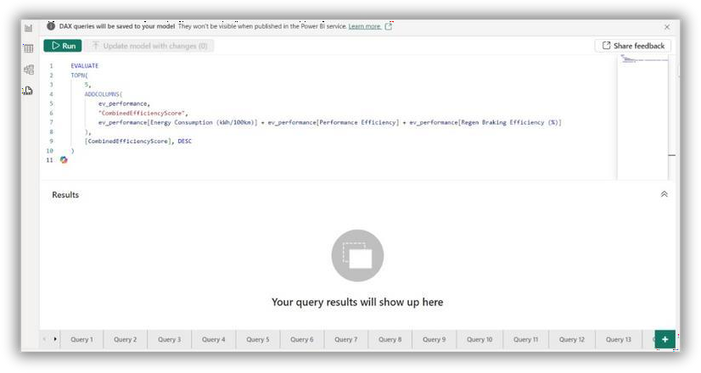

Once relevant features are identified, building calculated data values through DAX (Data Analysis Expressions) becomes crucial. DAX allows users to create custom formulas for various calculations, like total sales, average wait times, or percentage changes. This level of data manipulation transforms raw data into actionable insights by performing complex operations that update dynamically with real-time data. Common DAX functions include SUM, AVERAGE, and FILTER, each serving distinct purposes. For instance, calculating a Total Sales value with SUM or identifying transactions above a threshold with FILTER can help pinpoint trends in revenue or performance. More advanced DAX queries, like RANKX for ranking or DATESINPERIOD for time-based calculations, allow students to build powerful analytics.

##### Project Development:

Students will create visualizations and dashboards based on the dataset.

In Power BI, students will use their dataset to create visualizations and dashboards that bring their analysis to life. Visualizations, such as bar charts, line graphs, and heat maps, help highlight trends, compare metrics, and identify patterns in a clear, visual format. By combining multiple visual elements into a cohesive dashboard, students can present a holistic view of their data, making it easier to track key performance indicators and gain actionable insights. Interactive dashboards also allow users to filter and drill down into specific areas, enhancing the data exploration experience.

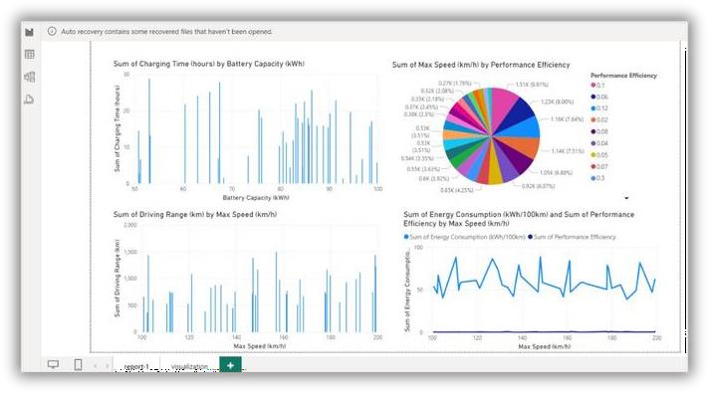

Completing reports and publishing to a cloud warehouse (Power BI Service).

After building their analyses and dashboards in Power BI, students will complete their reports and publish them to the Power BI Service, a cloud-based platform that enables secure data sharing and collaboration. By publishing to this cloud warehouse, students can make their reports accessible to others in real time, allowing stakeholders or team members to view, interact with, and gain insights from the data directly. Power BI Service also supports automated data refreshes, ensuring that reports stay up-to- date with the latest information.

**Project Presentation:**

Each student or group will present their project findings and visualizations to showcase the insights derived from their analysis. During the presentation, they will explain the rationale behind their chosen features, demonstrate how they used DAX functions for custom calculations, and walk through their dashboards, highlighting key trends and metrics. This presentation allows them to practice articulating data insights and making complex information understandable for an audience. Additionally, it offers an opportunity for constructive feedback, encouraging students to refine their analytical approach and gain confidence in communicating data-driven conclusions effectively.

